From: https://rwmalonemd.substack.com/p/all-along-the-watchtower?token=eyJ1c2VyX2lkIjoyMjk3ODczNiwicG9zdF9pZCI6NTAwMDcwODgsIl8iOiJ5aC9PbiIsImlhdCI6MTY0Njg0MzAwNywiZXhwIjoxNjQ2ODQ2NjA3LCJpc3MiOiJwdWItNTgzMjAwIiwic3ViIjoicG9zdC1yZWFjdGlvbiJ9.n4CLBDwIFpT4tF8waKruR6IfcF6Qz2zEanc-tYVRN7w&s=r
Keywords: biodefense, mass formation psychosis, transhumanism,

All Along the Watchtower

Would the Russian invasion of Ukraine be justified if it were for biodefense?

 | Robert W Malone MD, MS
  50 min ago

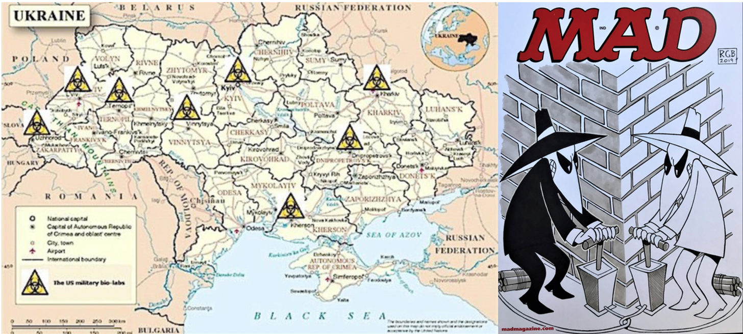
"There must be some way out of here"
Said the joker to the thief
"There's too much confusion
I can't get no relief
Businessmen, they drink my wine
Plowmen dig my earth
None of them along the line
Know what any of it is worth"
Before I was de-platformed by Twitter for posting the famously accurate Canadian COVID Care Alliance video, before I was de-platformed by LinkedIn for the same reason, before the infamous Joe Rogan hit #1757 where I said the three little words “mass formation psychosis” that caused the Silicon Valley overlords to loose bladder control, many feared that I was “controlled opposition”. And for good reason.
I have spent most of my career deeply involved in the US Biodefense enterprise. I have worked closely with biodefense research teams at USAMRIID, DTRA, and MIT Lincoln Lab. I was once a business partner with a retired CIA officer who was deeply involved in the DoD biodefense enterprise, and I have co-published with another. I once worked for the Dynport Vaccine Company, which had the DoD contract for “advanced development” (basically, clinical testing) of virtually all biodefense medical countermeasures for the US Department of Defense. My father worked as a federal defense contractor all his life, as did my father in law. In my father’s case, it was mostly in high energy systems- including developing technologies for protection against the electromagnetic surge effects of “the bomb” as well as exploding foil – the technology used to trigger “the bomb”. My father in-law ran the Raytheon special projects division – basically a CIA gadget and technology shop. Think “Q” from the James Bond series. This is a byzantine world that I have deep understanding of, and direct experience with for virtually my entire life. I lived by the mantra which all DC bureaucrats know – keep your head down, because if they cannot see you, they cannot shoot you.
But I never really allowed myself to confront the possibility that we might not be the good guys, the white hats. Until I experienced what we have all been through over the last two years. A government (or really multiple governments) that clearly believes that it is justified in disregarding fundamental principles of bioethics and the common rule. And like many others, once I saw that, it was like having backed into a light switch and suddenly the entire room was lit up, and I could never un-see what was revealed. Are we always the good guys? Or is this just more interchangeable Spy vs Spy, where ethics and roles and fungible and “situational”. A world in which there are no good guys, no white hats. Just a matter of media spin, perspective, and realpolitik. The world as envisioned by Henry Kissinger and Klaus Schwab.
And by the way, “biodefense” is big business. Yet more weapons of war.
Most of us that are not deep into the mass formation process at this point can see the coordinated pivot from legacy media pushing the COVID fear-porn to the same outlets pushing the “Putin crazy bad man - Zelenskyy good man” theme. But almost as soon as the shooting war started, a more nuanced and complex counter-narrative cropped up. That is
- the deep ties between children of key Democratic party leaders and Ukrainian petroleum industry interests.
- And the USA-sponsored bioweapon research facilities located throughout Ukraine, including along the Russian border.
- And the legitimate Russian concerns about NATO efforts to geopolitically encircle Russia.
- And the issue of whether Zelenskyy is really just a western puppet, rather than being the populist leader that has been pitched to us.
- And the surreptitious hand of World Economic Foundation meddling in all of this.
Things started looking a lot more complicated that just “Putin crazy bad man - Zelenskyy good man”.
I love to illustrate key points with stories based on personal experience. I have been told by people who would know (including Major General (ret.) Philip K. Russell, MD), that over many decades, the total expenditures of the US Government in developing biowarfare agents exceeded the money spent on thermonuclear weapons. A case can be made that modern understanding and technology relating molecular biology, microbiology, and virology is fundamentally a “civilian” byproduct of a massive investment in biowarfare tech by US, USSR, and other governments.
The latest evolution of these technologies is that we appear to have the CCP of the People’s Republic of China, which seems to recognize no ethical boundaries, pushing the limits of the brave new world of “transhumanism”. Which in turn becomes a justification for western nations basically making the argument that “since they are doing it, we have to do it”. An increasingly sophisticated next generation of biological warfare. Where people become the weapons of choice for governments that give us no choice. For further on that, please see our prior Substack "Human Augmentation – The Dawn of a New Paradigm".
Back to my story to illustrate just what we are up against here, as told by those I used to hang with (who may be inflating their self importance). The history that was relayed to me is that the real event which catalyzed the fall of the former Soviet Union was actually the development breakthrough of a binary (two part) bioweapon which could be delivered via an airborne route. So lethal was this weapon, that it could basically stop tank commanders and their crews in their tracks. According to this version of reality, the major military tension and strategic concern between the former USSR and Western Europe involved Russian Tank battalions which were poised to be able to blitzkrieg all the way to the English Channel. A threat which the western European states were acutely aware of, consequent to Hitler having successfully deployed the same strategy. The west basically had no way to mitigate this threat, or so the story goes, so it [that threat] was always hanging over any geopolitical tensions which would arise from time to time between the European NATO states and the USSR. Apparently the binary biologic was so potent that it would kill or incapacitate the tank crews so quickly that it negated the risk of blitzkrieg. Of course, this is just one story, told to me by friends in high places - so unverified. Be that as it may.
The point is that biological warfare agents are potent, cheap, easy to manufacture (particularly compared to thermonuclear devices), readily deployed, and have changed the tide of history on many occasions. Back to the “Indian” wars, where smallpox was basically weaponized from time to time against indigenous peoples in North America. And probably all the way back through recorded history.
So now we have the emerging rich documentation of US sponsored bio labs scattered across what had increasingly become the US client state called Ukraine.
If you want to dip your toe into that topic, dive down that rabbit hole, please see the following:
“EXCLUSIVE: Deleted Web Pages Show Obama Led an Effort To Build a Ukraine-Based BioLab Handling ‘Especially Dangerous Pathogens’”
“BREAKING: Biden official says US working with Ukraine to prevent bio research facilities from falling into Russian hands”
“US Embassy Quietly Deletes All Ukraine Bioweapons Lab Documents Online – Media Blackout”
“China urges U.S. to release details of bio-labs in Ukraine”
“China urges US to reveal details of US-backed biological labs in Ukraine – including types of viruses stored”
“Russia Negotiator Charges It Now Has Evidence of ‘Biological Weapons Components’ in Ukraine That Show ‘Good Reason’ for Invasion”
“WHAT HAVE FAUCI’S FRIENDS BEEN UP TO IN UKRAINE?”
Here’s the point. Once upon a time, the US engaged in thermonuclear war brinksmanship with the USSR because of Russian missiles being placed on Cuban soil. The weapons of war have evolved. Bioweapons technologies have matured. What would the USA do if Russia was transforming Mexico into a client state and had placed biowarfare research laboratories along our southern border. Would we invade? I strongly suspect so.
Are “we” the good guys or the bad guys here?

From: https://rwmalonemd.substack.com/p/all-along-the-watchtower/comments?s=r
 | All Along the Watchtower  Would the Russian invasion of Ukraine be justified if it were for biodefense?  Read →
  Robert W Malone MD, MS | 46 min ago | 312 | 48



Top First

 | Bash  33 min ago  There has been something odd about the intensity of the Western reaction to Ukraine. I mean, to all out cancel an entire nation, hoover up private property of private citizens for the crime of having a Russian passport, and flirt with starting ww3.. for Ukraine?  Something is off  51Reply

JSand
28 min ago
It's astounding to me that we've been lied to by the media for the last two years and now people are going back to believing everything the media is putting out regarding Russia.
The ability to cancel an entire nation means that in the future folks like you, me and Dr. Malone will be cut off for wrong think. That is, if the WEF and blackrock has their way.

39Reply

Bash
23 min ago
To be honest, if it wasn't for the covid calamities, I would have been swallowing what the WSJ and sorts are saying without much skepticism. last 2 years have really opened my eyes; and in a sense I miss the blissful ignorance.

22Reply
Boris Petrov
19 min ago
Remember the extreme bipartisan reaction when clown Trump stated -- let's be friends with capitalist Russia.

4Reply

Aimee
15 min ago·edited 15 min ago
Trump was a “peace through trade” kind of guy. Anti war. I’m puzzled that Biden is now so close to the Cheney’s. But looking back, it does explain a lot of things over the past few decades. Uniparty is an actual thing, and Trump wanted no part of it. He is hated by both parties for a REASON.

13Reply
Aimee
29 min ago
I’m pretty sure the U.S. government and its lapdog media are lying about almost everything. That’s my default position based on the past year, and I’m quite comfortable with it.

30Reply

JSand
36 min ago
When you gaze into the bio-lab, the bio-lab gazes also into you. Thanks for helping us removed the scales from our eyes Dr. Malone

30Reply
Susanna
37 min ago·edited 37 min ago
So interesting that you just published this article the same morning I had to read Alex Berenson mock anyone that might think this could be part of the reason of the invasion.
What about this hypothesis - Russia invaded for a variety of complex reasons (over my head), and the US is now frantically aware that they need to batten down their bioweapon facilities before the Russians get their hands on them? That seems plausible too.

23Reply

Robert W Malone MD, MS
34 min ago
oh, you mean like...
the analogy I also made at the end of the essay about if the USA were transforming Mexico into a client state.
as well as listing these:
That is the deep ties between children of key Democratic party leaders and Ukrainian petroleum industry interests.
And the legitimate Russian concerns about NATO efforts to geopolitically encircle Russia.
And the issue of whether Zelenskyy is really just a western puppet, rather than being the populist leader that has been pitched to us.
And the surreptitious hand of World Economic Foundation meddling in all of this.

32Reply

Susanna
33 min ago·edited 31 min ago
I'm on your side, Robert. I liked your article. Sorry if you took my comment differently. And yes, all of those reasons you mentioned. I don't claim to understand anything going on over there - I'm just skeptical of anything MSM tells me about it.

13Reply
Proud citizen
25 min ago
Brilliantly stated. Take care of yourself Dr Malone.

14Reply

………………………………………………..
………………………………………….

